# JRD301: Mini Project in Robotics (Second Semester 2019‐20)

Weekly Progress Report (From: 27/01 /2020 To: 31/01/2019)

I undertake that the following work has been accomplished during the above mentioned period of one week (please write in bulleted points):

* In order to reduce sudden variations in centre detection, we started storing the x coordinate of the centre of the road and the heading direction of the car detected in arrays of length 200 and 100 respectively.
* When there was no sudden deflection in the detected value, we updated the array by adding the detected value and removing the least recent value. We used the average of all the values in the array for control.
* When there was a sudden deflection, we flushed the array and continued giving the last control.
* We implemented control using ROS. We subscribed to the ‘/zed/image_raw’ topic to get the images detected by the ZED camera and processed the image to determine the steering angle which was published in the topic ‘/steer’.

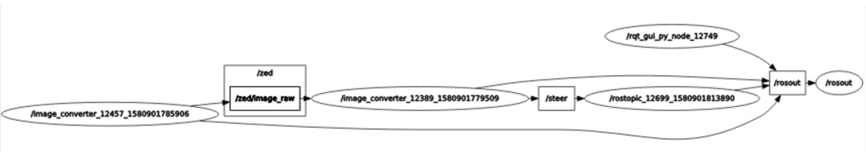

# Fig 1: rqt_graph of ros topics and nodes used

# Submitted by (student’s name with signature) Endorsed by:

Group member 1: Harman Mehta (2016BB50003) Supervisor 1: Prof. Sunil Jha

Group member 2: Tanmay Goyal (2016ME20757)